INSTALLATION AND MAINTENANCE:
The Global Communication project can be installed on the computer using the following steps:
- Install j2sdk1.4.2_04
- Install Tomcat 5.0 Web Server
We are using the Default port number 8080(this is up to user choice)
Update Environment variables with the following values
ClassPath =
.;c:\j2sdk1.4.2_04\lib\tools.jar;c:\j2sdk1.4.2_04\jre\lib\rt.jar;c:\Oracle\Ora81\jdbc\lib\classes111.zip;c:\Oracle\Ora81\jdbc\lib\classes111.jar;c:\Oracle\Ora81\jlib\oraclexmlsql.jar;c:\Oracle\Ora81\jlib\xmlparserv2.jar;c:\Oracle\Ora81\jdbc\lib;c:\Oracle\Ora81\jdbc\lib\oracle\;c:\Oracle\Ora81\jlib\jlib\;C:\Tomcat 5.0\common\lib\servlet-api.jar

Path =
C:\Oracle\Ora81\bin;C:\j2sdk1.4.2_04\bin;C:\Tomcat 5.0\bin;c:\j2sdk1.4.2_04\lib
- Install Oracle 8i (8.1.5.0.0)
Create Oracle DSN’S: kishor, vijay
- Copy and paste gcmedia(code) folder in C:\Tomcat 5.0\webapps
- Start Tomcat Web Server from start menu.

Create the following Oracle Tables
SQL> desc empdetails
Name Null? Type
----------------------------------------------------- -------- ----------------
EMPID NUMBER
KEY VARCHAR2(10)
AC_STATUS VARCHAR2(1)
DOJ VARCHAR2(10)
USERID VARCHAR2(25)

SQL> desc addressbook
Name Null? Type
----------------------------------------------------- -------- ----------------
NAME VARCHAR2(40)
USERID VARCHAR2(20)
DOB VARCHAR2(14)
EMAIL VARCHAR2(40)
PHONE VARCHAR2(16)
CITY VARCHAR2(30)
OUSERID VARCHAR2(25)

SQL> desc advices
Name Null? Type
----------------------------------------------------- -------- ----------------
NAME VARCHAR2(50)
PHONE VARCHAR2(14)
EMPID VARCHAR2(6)
ADDRESS VARCHAR2(40)
MESSAGE VARCHAR2(500)

SQL> desc clientonline
Name Null? Type
----------------------------------------------------- -------- ----------------
USERID VARCHAR2(25)
ROOMNAME VARCHAR2(20)
DATEOFLOG VARCHAR2(25)
TIMEOFLOG VARCHAR2(25)

SQL> desc mail
Name Null? Type
----------------------------------------------------- -------- ----------------
USERID VARCHAR2(25)
WHOSEND VARCHAR2(25)
MESSAGE LONG
TIMING VARCHAR2(50)
READ CHAR(1)
SUBJECT VARCHAR2(25)

SQL> desc password
Name Null? Type
----------------------------------------------------- -------- ----------------
USERID VARCHAR2(25)
PWD VARCHAR2(20)
BAN VARCHAR2(1)

SQL> desc roomdetails
Name Null? Type
----------------------------------------------------- -------- ----------------
ROOMNAME VARCHAR2(25)
RIN VARCHAR2(20)
MODERATOR VARCHAR2(25)

SQL> desc userdetails
Name Null? Type
----------------------------------------------------- -------- ----------------
USERID VARCHAR2(25)
NAME VARCHAR2(60)
ADDRESS VARCHAR2(120)
ZIP VARCHAR2(6)
PHONE VARCHAR2(12)
EMAIL VARCHAR2(50)
SEX VARCHAR2(1)
EDUCATION VARCHAR2(30)
COUNTRY VARCHAR2(25)
CITY VARCHAR2(20)
STATE VARCHAR2(25)
DOB VARCHAR2(12)

SQL> desc security
Name Null? Type
----------------------------------------------------- -------- ----------------
USERID VARCHAR2(25)
QUES VARCHAR2(100)
ANS VARCHAR2(50)

Run the following queries
- insert into password values(`admin’,`admin’,`n’);
- insert into empdetails values(‘c1001’,’admin’,’y’,’12/05/2005’,’admin’);
- insert into security values(‘admin’,’who am I’,’admin’);
- insert into userdetails values(‘admin’,’Administrator’,’Room No:227, Hostel-A, University of Hyderabad’,’500046’,’9885250577’,’kvbreddymca@yahoo.com’,
’m’,’mca’,’india’,’Hyd’,’Ap’,’23/08/1980’);
After running server........
Open Internet Explorer
give url :-= http://localhost:8080/project/index.html
Now u will get the following screen
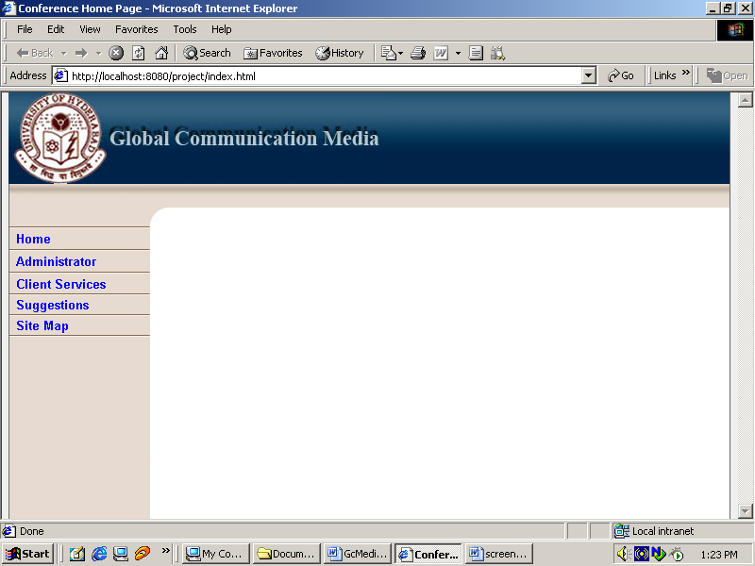
Click on Administrator
Then it will prompt u for Admin id And password
Enter Admin id = admin
Password = admin
Now u will be succeeded with welcome screen…………..
Admin has to add employees, all these u can get from interface.

